

**Western Australian Certificate of Education**

**ATAR course examination, 2018**

**Question/Answer Booklet**

11 PHYSICS

Name

**Test 4 - Electricity**

|  |  |  |  |  |  |  |  |  |  |  |
| --- | --- | --- | --- | --- | --- | --- | --- | --- | --- | --- |
| Student Number: In figures |  |  |  |  |  |  |  |  |  |  |

**Mark: $\frac{}{\text{5}\text{8}}$**  In words

#### Time allowed for this paper

Reading time before commencing work: five minutes

Working time for paper: fifty minutes

**Materials required/recommended for this paper**

To be provided by the supervisor

This Question/Answer Booklet

Formulae and Data Booklet

***To be provided by the candidate***

Standard items: pens, (blue/black preferred), pencils (including coloured), sharpener, correction fluid/tape, eraser, ruler, highlighters

Special items: non-programmable calculators satisfying the conditions set by the School Curriculum and Standards Authority for this course

**Important note to candidates**

No other items may be taken into the examination room. It is your responsibility to ensure that you do not have any unauthorised notes or other items of a non-personal nature in the examination room. If you have any unauthorised material with you, hand it to the supervisor before reading any further.

**Structure of this paper**

|  |  |  |  |  |  |
| --- | --- | --- | --- | --- | --- |
| Section | Number of questions available | Number of questions to be answered | Suggested working time  (minutes) | Marks available | Percentage of exam |
| Section One:  Short Answers |  |  |  |  |  |
| Section Two:  Problem-solving | 12 | 12 | 50 | 58 | 100 |
| Section Three:  Comprehension |  |  |  |  |  |
|  |  |  |  | **Total** | 100 |

**Instructions to candidates**

1. The rules for the conduct of examinations at Holy Cross College are detailed in the College Examination Policy*.* Sitting this examination implies that you agree to abide by these rules.

2. Write your answers in this Question/Answer Booklet.

3. Working or reasoning should be clearly shown when calculating or estimating answers.

4. You must be careful to confine your responses to the specific questions asked and to follow any instructions that are specific to a particular question.

5. Spare pages are included at the end of this booklet. They can be used for planning your

responses and/or as additional space if required to continue an answer.

• Planning: If you use the spare pages for planning, indicate this clearly at the top of the page.

• Continuing an answer: If you need to use the space to continue an answer, indicate in the original answer space where the answer is continued, i.e. give the page number.

Fill in the number of the question(s) that you are continuing to answer at the top of the page.

6. Answers to questions involving calculations should be ***evaluated and given in decimal***

***form*.** It is suggested that you quote all answers to ***three significant figures***, with the

exception of questions for which estimates are required. Despite an incorrect final result, credit may be obtained for method and working, providing these are ***clearly and legibly set out***.

7. Questions containing the instruction "estimate" may give insufficient numerical data for their solution. Students should provide appropriate figures to enable an approximate solution to be obtained. Give final answers to a maximum of two significant figures and include appropriate units where applicable.

8. Note that when an answer is a vector quantity, it must be given with magnitude and direction.

9. In all calculations, units must be consistent throughout your working.

**Circle the correct answer in the following four questions.** [4 marks]

1. The lower slot of any power point in your home will enable a connection to:

(a) the active part of the supply circuit.

(b) the neutral part of the supply circuit.

(c) the earth wiring in your home.

(d) a residual current device (RCD).

2. Which of the following is the correct definition for electrical current?

(a) The charge per unit volume per unit time.

(b) The charge per unit volume.

(c) The charge per unit time.

(d) The time per unit charge.

3. How does the total resistance of two identical resistors in parallel (*R*tot) compare to the resistance of the individual resistors (*R*)?

(a) *R*tot = *R*

(b) *R*tot < *R*

(c) *R*tot > *R*

(d) It depends on the resistance, *R*.

4. How much current is drawn by a 6.00 W torch globe that utilises two 1.50 V cells placed in series?

(a) 0.500 A

(b) 4.00 A

(c) 9.00 A

(d) 2.00 A

5. A battery in a circuit has current of 4.50 A passing through it.

(a) How many coulombs of charge pass through the battery in 5.00 seconds? [2 marks]

(b) If the battery provides a potential difference of 9.00 V, how many joules of energy (work) does it provide to the circuit each second? (3 marks)

6. (a) How much energy (in ***kilowatt-hours*** and ***joules***) will a 2.00 x 102 W globe use in

4.00 hours of operation? [4 marks]

(b) An electricity company charges 30.0 cents per kilowatt hour (kWh) of electricity consumed. How much does it cost to use this 2.00 x 102 W globe for 2.50 hours?

[3 marks]

7. Two electrical devices have current–voltage characteristics as shown below.

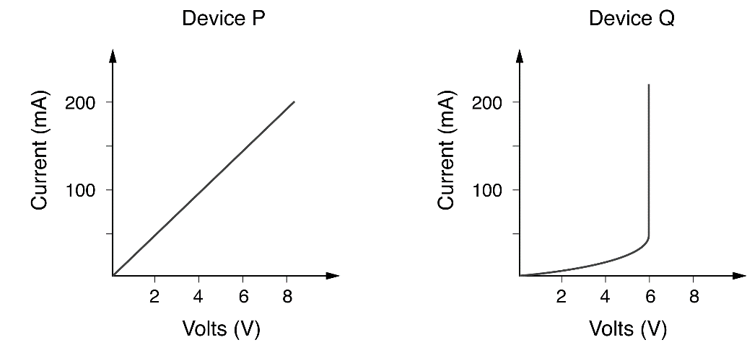

(a) Which of the two components obeys Ohm’s law? [1 mark]

(b) Determine the resistance of this device. [4 marks]

(c) (i) What is the effective resistance of the other device when a current of

2.00 x 102 mA flows through it? [2 marks]

(ii) Would this value remain constant? Explain your answer. [2 marks]

8. A student set up an ammeter and a voltmeter in a simple circuit in order to measure the current and potential difference across her torch globe (light bulb) in the laboratory.

(a) Sketch a diagram to show how the student should place the ammeter and the voltmeter in her simple circuit. Include a switch and power source in your diagram.

[3 marks]

(b) Explain why ammeters and voltmeters must be placed in this way. [2 marks]

9. If a person runs all of the following appliances at the same time, will the fuse blow (melt)?

*A 4.00 x 102 Ω refrigerator, a 30.0 Ω heater and an 80.0 Ω microwave oven.*

The appliances are all connected in ***parallel*** to a 2.40 x 102 V mains supply power point and the fuse in the circuit is rated at 10.0 amps. Explain your reasoning. [5 marks]

10. (a) Explain why it may be dangerous to operate a 240 V hair dryer in a bathroom.

[2 marks]

(b) Describe ***two*** different safety features of our mains electricity supply system and how they act to protect us. [4 marks]

11. In the circuit below, there is a 25.0 mA current in the 1.00 x 102  resistor.

**A** 40 Ω

**B** 25 Ω

**D** 12 Ω

**C** 100 Ω, 25 mA

V

(a) Determine the potential difference across the 1.00 x 102  resistor. [2 marks]

(b) Calculate the total current that flows in the circuit. [4 marks]

(c) What voltage must be supplied by the source? [5 marks]

(d) Calculate the power dissipated in the 12.0  resistor as heat. [3 marks]

12. In the electron gun in an old colour TV tube, the potential difference used to accelerate electrons is 1.50 kV. Calculate the speed at which electrons leave the gun, assuming that they have no speed as they leave the cathode (negative electrode) inside the gun.

[3 marks]